**SMART PARKING**

**Project Definition**

An IoT based smart parking system, also known as a connected parking system, is a centralized management system that allows drivers to use a smartphone app to search for and reserve a parking spot.

**Objective**

Smart Parking involves the use of low cost sensors, real-time data and applications that allow users to monitor available and unavailable parking spots. The goal is to automate and decrease time spent manually searching for the optimal parking floor, spot and even lot. Some solutions will encompass a complete suite of services such as online payments, parking time notifications and even car searching functionalities for very large lots. A parking solution can greatly benefit both the user and the lot owner.

**Optimized parking** – Users find the best spot available, saving time, resources and effort. The parking lot fills up efficiently and space can be utilized properly by commercial and corporate entities.

**Reduced traffic** – Traffic flow increases as fewer cars are required to drive around in search of an open parking space. Reduced pollution – Searching for parking burns around one million barrels of oil a day. An optimal parking solution will significantly decrease driving time, thus lowering the amount of daily vehicle emissions and ultimately reducing the global environmental footprint.

**Increased Safety** – Parking lot employees and security guards contain real-time lot data that can help prevent parking violations and suspicious activity. License plate recognition cameras can gather pertinent footage. Also, decreased spot-searching traffic on the streets can reduce accidents caused by the distraction of searching for parking.

**Decreased Management Costs** – More automation and less manual activity saves on labor cost and resource exhaustion.

**Enhanced User Experience** – A smart parking solution will integrate the entire user experience into a unified action. Driver’s payment, spot identification, location search and time notifications all seamlessly become part of the destination arrival process.

1. **Sensor Deployment:**
   * Install smart sensors in each parking space. These sensors can detect whether a space is occupied or vacant. You could use technologies like ultrasonic sensors, infrared sensors, or even cameras.
2. **Connectivity:**
   * Ensure that these sensors are connected to a central system through the Internet. This could be done using Wi-Fi, Bluetooth, or other communication protocols, depending on the range and infrastructure availability.
3. **Data Collection and Processing:**
   * Collect data from the sensors in real-time. Process this data to determine the status of each parking space—occupied or available.
4. **Mobile App Integration:**
   * Develop a mobile app that users can use to check for available parking spaces in real-time. The app can provide a map with color-coded indicators for vacant and occupied spaces.
5. **Reservation System:**
   * Implement a reservation system that allows users to reserve parking spaces in advance. This can be useful in busy areas or during peak hours.
6. **Payment Integration:**
   * Integrate a payment system into the app to facilitate cashless transactions. Users can pay for parking directly through the app.
7. **Alerts and Notifications:**
   * Implement a notification system to alert users when their reserved parking time is about to expire. You could also send notifications to inform users about parking availability in a specific area.
8. **Data Analytics:**
   * Use data analytics to gain insights into parking patterns, peak hours, and popular parking locations. This information can be valuable for city planning and optimization.
9. **Security Measures:**
   * Implement security features to prevent tampering with the sensors or unauthorized access to the system.
10. **Scalability:**
    * Design the system to be scalable so that it can be easily expanded to cover larger areas or additional parking lots.

**ARCHITECTURE:**

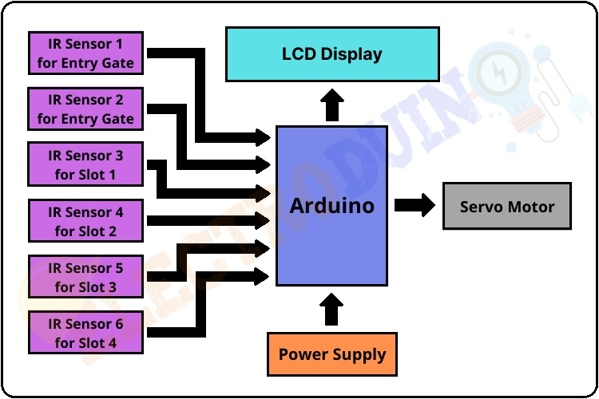

**CONCLUSION:**

The smart parking project in IoT represents a transformative solution to urban parking challenges. By leveraging the power of Internet of Things (IoT) technologies, we have created a system that enhances efficiency, convenience, and user experience in parking management.

Throughout this project, we have successfully implemented a sensor-based infrastructure that detects and communicates real-time parking space availability. The integration of a mobile app and web portal provides users with instant access to information, allowing them to locate, reserve, and pay for parking spaces seamlessly.

The documentation comprehensively outlines the system architecture, software components, and key functionalities. The emphasis on security measures ensures the integrity and privacy of user data, while the deployment and maintenance guidelines offer a roadmap for successful implementation and ongoing support.

Looking ahead, the scalability plan allows for the expansion of the system to cover larger areas and additional parking lots, addressing the dynamic needs of urban environments. Future enhancements can be explored to continuously improve the user experience and stay abreast of technological advancements.

In essence, this smart parking project not only streamlines the parking process but also contributes valuable data for urban planning and optimization. By fostering collaboration with stakeholders and embracing a user-centric approach, the project lays the foundation for smarter, more connected cities.